*The risks of shell-boring polychaetes to shellfish aquaculture in Washington, USA: a mini-review to inform mitigation actions*

Laura H Spencer1, Julieta C Martinelli1, Teri L King2, Ryan Crim3,

Brady Blake4, Heather M Lopes1,Chelsea L Wood1

1School of Aquatic and Fishery Sciences, University of Washington, Seattle, WA 98105

2Washington Sea Grant, University of Washington, Shelton, WA 98584

3Puget Sound Restoration Fund, Bainbridge Island, WA 98110

4Washington State Department of Fish and Wildlife, Olympia, WA 98501

Corresponding author: Laura H Spencer, lhs3@uw.edu

Keywords: Polydora, mudworm, invasive species, oyster

Short running title: *Minimizing impacts of shell-boring polychaetes*

**Abstract**

In 2017, *Polydora websteri*, a shell-boring spionid polychaete worm and cosmopolitan invader, was identified for the first time in Washington State. *Polydora websteri* and some of its congeners bore into the shells of calcareous marine invertebrates, reducing the host’s shell integrity, growth, survivorship, and market value. Shell-boring *Polydora* spp. have a history of harming shellfish aquaculture industries worldwide by devaluing products destined for the half-shell market, and requiring burdensome treatments and interventions to manage against infection. Here, we explore the risks of *Polydora* spp. to the historically unaffected aquaculture industry in Washington State. This mini-review is intended to inform shellfish stakeholders by integrating information pertinent to immediate action. We discuss *Polydora* life history andpathology, summarize the recent observations in Washington State and its history as a pest species globally, including farm management strategies developed in other infested regions. We then propose measures that stakeholders could take in the context of existing regulations to investigate and mitigate the risks of *Polydora* spp. to shellfish aquaculture to avoid further human-aided spread.

**Introduction**

In 2017, shell-boring *Polydora* spp*.* polychaete worms were positively identified in Washington State (Figure 1), including the notorious, cosmopolitan invader *Polydora websteri* (Martinelli et al. in review). These parasitic marine polychaetes in the family Spionidae bore into the shells of calcareous marine invertebrates, and may pose a risk to cultured and native shellfish species [(Lunz 1941; Simon and Sato-Okoshi 2015)](https://paperpile.com/c/RcvCBz/8XqE+F2RV). Prior to positive identification in 2017, no native or introduced

other*Polydora* spp. are colloquially known as mud worms, or mud blister worms, and have a long history of reducing shellfish aquaculture production and value in regions such as Australia [(Ogburn 2011)](https://paperpile.com/c/RcvCBz/LMsc), New Zealand [(Handley and Bergquist 1997)](https://paperpile.com/c/RcvCBz/WPs1), Chile [(Moreno](https://paperpile.com/c/RcvCBz/JyHC) *[et al](https://paperpile.com/c/RcvCBz/JyHC)*[. 2006; Riascos](https://paperpile.com/c/RcvCBz/JyHC) *[et al.](https://paperpile.com/c/RcvCBz/JyHC)* [2008)](https://paperpile.com/c/RcvCBz/JyHC), Hawaii [(Eldredge 1994; Bailey-Brock and Ringwood 1982; Bailey-Brock 1990)](https://paperpile.com/c/RcvCBz/Kv1B+BK00+fHEw), the East and Gulf coasts of the United States [(Lafferty and Kuris 1996; Lunz 1941; Loosanoff and Engle 1943; Brown 2012)](https://paperpile.com/c/RcvCBz/XYJg+8XqE+4Xo6+LCY4), , and British Columbia. Despite previous observations of *P. websteri* in nearby regions such as British Columbia in 1989 [(Bower](https://paperpile.com/c/RcvCBz/tkTE) *[et al.](https://paperpile.com/c/RcvCBz/tkTE)* [1992)](https://paperpile.com/c/RcvCBz/tkTE), neither benthic surveys or shellfish growers have historically identified shell-boring mud worms in Washington State. The worm’s invasion history and basin-wide infestation rates are unknown, however the 2017 study reports that *Polydora* prevalence was as high as 53% in one embayment of South Puget Sound (Martinelli et al. *in review*) and suggests that infestation rates may have recently increased to noticeable levels.

Given *Polydora’s* negative impacts on shellfish aquaculture in other regions, its presence in Puget Sound warrants a region-focused review to inform further investigation and stakeholder awareness. Here, we explore *Polydora* spp. as a potential risk to Washington State aquaculture. We summarize *Polydora* pathology and life history, review the recent discovery in Washington State, then discuss its history as a pest species, translocation in other regions, and finally propose measures that stakeholders could take to mitigate the risks of *Polydora* spp. to Washington State shellfish aquaculture given existing regulations.

**Host pathology**

Infection by boring *Polydora* spp. can reduce the host’s shell integrity, growth, survivorship, and market value [(Simon and Sato-Okoshi 2015)](https://paperpile.com/c/RcvCBz/F2RV). *Polydora* spp. worms bore into calcareous shells and line their tunnel with shell fragments, mucus, and detritus (Figure 2) [(Wilson 1928; Zottoli and Carriker 1974)](https://paperpile.com/c/RcvCBz/WIS1B+mYiIY). If the tunnel breaches the inner shell surface, the host responds by laying down a layer of nacreto protect itself from the burrow and the worm [(Whitelegge 1890; Lunz 1941)](https://paperpile.com/c/RcvCBz/3OMWW+8XqE). This can produce a blister, where a thin layer of shell lies over a mass of anoxic detritus. In oysters, the blister is unsightly, its contents malodorous, and if the blister is breached during shucking the detritus can contaminate oyster meat and brine, detracting from flavor and presentation (Morse et al. 2015). Since half-shell oysters are the most lucrative option for farmers, and *Polydora* infected oysters are often are not sellable to the half-shell market, infection significantly depreciates oyster products.

*Polydora* infection can also devalue other oyster products by compromising growth and survival. *Polydora* worm burden is negatively correlated with growth rate, and while the mechanisms are not fully understood, this may be due to the energetic drain of nacre production [(Simon 2011; Boonzaaier et al. 2014; Lleonart et al. 2003; Kojima and Imajima 1982; Wargo and Ford 1993; Royer et al. 2006)](https://paperpile.com/c/RcvCBz/fCuiB+UcuCB+6uzt+UbCiT+QfddC+kcElC). Pacific oysters (*C. gigas)* infected with *P. websteri* grows more slowly, exhibits more frequent but shorter valve gaping, and has higher blood oxygenation [(Chambon et al. 2007)](https://paperpile.com/c/RcvCBz/dqCHX). Infected *C. gigas* also demonstrate a three-fold increase Cytochrome P450 abundance, a protein involved in the oyster’s stress response, which could increase susceptibility to secondary stressors [(Chambon et al. 2007)](https://paperpile.com/c/RcvCBz/dqCHX). Shell strength is negatively correlated with *P. ciliata* burden in the mussel *Mytilus edulis,* which increases vulnerability to predation [(Kent 1981)](https://paperpile.com/c/RcvCBz/ncAce). Interestingly, fecundity increases in *P. websteri-*infected *Striostrea margaritacea*, a rock oyster (Schleyer 1991)*.* These oysters could be exhibiting a response to stress from infection by reproducing while resources allow it. Similar phenomena have been documented in nematode-parasitized mice, which produce larger litters than uninfected mice [(Kristan 2004; Schleyer 1991)](https://paperpile.com/c/RcvCBz/9CvPh+tuA23) and plants that prematurely reproduce (“bolt”) during periods of drought [(Barnabás et al 2008)](https://paperpile.com/c/RcvCBz/mUXd1).

***Polydora* life history**

The impact of *Polydora* on shellfish aquaculture arises from its life history as a shell-borer.After a planktonic larval stage, a burrowing *Polydora* worm settles onto the prospective host’s shell and begins building a tunnel [(Wilson 1928; Loosanoff and Engle 1943; Blake 1969; Blake and Arnofsky 1999)](https://paperpile.com/c/RcvCBz/WIS1B+4Xo6+xO2XC+Mnlql). The worm enters along the margin of the shell and excavates its burrow toward the shell center, using its specialized segment, the 5th setiger, to stabilize its tunnel during burrowing and secretes a viscous fluid to dissolve the calcium carbonate shell material, [(Haigler 1969; Zottoli and Carriker 1974)](https://paperpile.com/c/RcvCBz/b4caa+mYiIY). The *Polydora* adult dwells within the tunnel, but can emerge from openings on the outer surface of the host’s shell to feed on particles in the water column and on materials on the shell surface (Figures 2, 3) [(Loosanoff and Engle 1943)](https://paperpile.com/c/RcvCBz/4Xo6).

Reproduction occurs when the male deposits sperm in a female’s burrow, and the female deposits egg cases along the burrow wall, with each case containing dozens of eggs. While species vary, one fecund female can produce hundreds of larval progeny [(Blake 1969)](https://paperpile.com/c/RcvCBz/xO2XC). It should be noted that some hermaphroditic species have been observed (e.g. *Polydora commensalis*) [(Hatfield 1965)](https://paperpile.com/c/RcvCBz/fKAWM). Larvae hatch from eggs and emerge from their maternal burrow and are free-swimming until they settle onto a substrate [(Orth 1971; Blake 1969)](https://paperpile.com/c/RcvCBz/EdUIq+xO2XC). Growth rate in the larval stage depends on ambient water temperature, thus the time spent in the water column differs between species and with environmental conditions, and may last as long as 85 days [(Blake and Woodwick 1971; Blake and Arnofsky 1999)](https://paperpile.com/c/RcvCBz/Nhtei+Mnlql). This potential for a long larval stage, particularly in colder climates, may allow for long dispersal distances [(Simon and Sato-Okoshi 2015)](https://paperpile.com/c/RcvCBz/F2RV). Additionally, in some instances, early hatched larvae can feed on underdeveloped eggs (“nurse eggs”), and complete development in the burrow [(Haigler 1969)](https://paperpile.com/c/RcvCBz/b4caa). This could result in an individual host’s parasitic burden compounding over time due to high rates of autoinfection.

**Recent identification in Washington State**

Historically, Washington shellfish farmers have not encountered shell-boring *Polydora* on their farms, and there were no species documented in the state. Related Spionid polychaetes have been present, such as *Polydora cornuta* (Fermer & Jumars 1999), *Pseudopolydora* spp. (*e.g.* Woodin 1984), and *Boccardia proboscidea* (Hartman 1940, Oyarzun et al. 2011). These are primarily benthic species, and while they can occupy mud deposits within oyster shell crevices, they do not burrow and therefore do not cause a damaging blister.

In 201? mud worm blisters were first noticed in cultured Pacific oysters from southern Puget Sound, which triggered a preliminary survey. Martinelli *et al.* (*in review)* sampled commercially produced Pacific oysters from Totten Inlet and Oakland Bay (Figure 1). Across both sites, 41% of oysters were infected with a shell-boring worm (53% of Oakland Bay oysters, 34% of Totten Inlet oysters) (Martinelli *et al.* in review). The worm species was identified using both morphometrics (from scanning electron microscope images), and phylogenetics (assigning 18s rRNA & mttCOI sequences against published *Polydora* sequences). Some of the worms collected from both oyster sources were positively identified as *P. websteri*, and others were determined to be cryptogenic species (phylogenetic trees from Martinelli *et al*. *in review* are reproduced in Figues 4 & 5).

Whether *P. websteri* has been present but dormant, or recently introduced is unknown. If the species was recently introduced, eradication may be possible (see Williams & Grosholz, 2008 for examples of successful programs). If eradication of *P. websteri* is not possible, it could still be contained to a few Puget Sound basins through education, mitigation, and regulation [(Çinar 2013; Paladini et al. 2017)](https://paperpile.com/c/RcvCBz/pTz3+ly4P+Exfx). If *P. websteri* has been present but dormant, the high infestation intensity reported by Martinelli et al. (*in review*) may be the result of a recent outbreak, caused by factors such as genetic changes, relaxation of biotic pressures (e.g. predators), or environmental changes (*e.g.* ocean warming, siltation) (Crooks 2005; Clements *et al.* 2017).

Washington State aquaculture produces 45% of the molluscs cultured in the US (2013, USDA) and is an iconic industry that supports rural communities, protects water quality, and collaborates closely with research and restoration programs. Within Washington, Puget Sound growers produce 70% of the state’s shellfish (80% by value, over $92 million annually), concentrated mostly in South Puget Sound, where the *Polydora*-infected oysters were sourced (Figure 1). Economic losses associated with *Polydora* outbreaks in this highly productive shellfish region could therefore be felt nationally.

**Impact on aquaculture production and management strategies in other regions**

*Polydora* infection has caused economic losses for aquaculture operations worldwide. The primary impact occurs due to negative consumer responses to worms, blisters, and anoxic material in products, particularly in freshly shucked oysters [(Shinn et al. 2015)](https://paperpile.com/c/RcvCBz/UtJP). No estimates exist of the revenue lost due to the effects of *Polydora* infection on shellfish growth and survival, but large mortality events suggest that *Polydora* can impact an industry via this mechanism as well. For example, in British Columbia, *P. websteri* caused up to 84% mortality in scallop grow-out sites from 1989 to 1990, resulting in up to US $449,660 in lost revenue that year [(Shinn et al. 2015; Bower et al. 1992)](https://paperpile.com/c/RcvCBz/UtJP+tkTE). In Tasmania and South Australia, *P. hoplura* killed over 50% of abalone stocks between 1995 and 2000, causing an estimated $0.55 to $1.16 million in losses per year [(Shinn et al. 2015)](https://paperpile.com/c/RcvCBz/UtJP). Other large-scale mortality events include infection in a Norwegian scallop nursery in the summer of 1997, when one million juvenile scallops were culled due to a *Polydora* spp. infestation; in total, one-third of Norway’s 1997 scallop cohort was lost [(Mortensen et al. 2000)](https://paperpile.com/c/RcvCBz/GeoC2). In 1998, intense infestations (up to 100 worms per oyster) of *P. ciliata* in *C. gigas* oysters in Normandy, France correlated with considerable reduction in growth and meat weight, which may have contributed to unusually high summer mortality rates of up to 51% [(Royer et al. 2006)](https://paperpile.com/c/RcvCBz/AtYlO). Of the shell borers, *P. websteri, P. ciliata,* and *P. hoplura* are the most widely distributed and notorious for invading and infecting shellfish farms [(Radashevsky et al. 2006)](https://paperpile.com/c/RcvCBz/5znG) (see Table 1). Non-boring species, such as *P. nuchalis* and *P. cornuta,* can also impact growers by fouling culture equipment with large masses of sediment and tubes [(Bailey-Brock 1990)](https://paperpile.com/c/RcvCBz/fHEw).

In regions with noxious *Polydora* spp., producers are burdened with costs of infection avoidance and control. Farm management approaches include modifying gear for off-bottom culture to keep products free of mud [(Ogburn et al. 2007; Morse et al. 2015)](https://paperpile.com/c/RcvCBz/yJ0u+32wY), increasing cleaning frequency to reduce siltation [(Clements et al. 2017)](https://paperpile.com/c/RcvCBz/YZpv), increasing tidal exposure time [(Morse et al. 2015)](https://paperpile.com/c/RcvCBz/32wY), and regular stock treatments. For example, Australian oyster farmers largely adopted off-bottom growing methods with long tidal exposures to reduce mud worm infestation rates (Smith 1981; Diggles 2013). Off-bottom methods have proven effective for avoiding infection, but this method does slow oyster growth rates [(Ogburn et al. 2007; Nell 2007; Nell 2001)](https://paperpile.com/c/RcvCBz/yJ0u+pnEn+7Oex).

A variety of treatments have been developed to kill worms once stocks are infected. Currently, the most effective method is the “Super Salty Slush Puppy” (SSSP), first developed by Cox et al. [(2012)](https://paperpile.com/c/RcvCBz/IbKwa). The protocol involves a 2-minute full submersion of oysters in brine (250 g/L) between -10°C and -30°C (i.e., ice-water), followed by air drying for 3 hours. The SSSP also effectively kills other fouling epibionts, such as barnacles. Petersen [(2016)](https://paperpile.com/c/RcvCBz/s92BU) recently compared the SSSP method against other saltwater, freshwater, and chemical dips followed by air exposure, and confirmed SSSP as the best method, killing 95% of *P. websteri* while causing only minimal mortality in *C. gigas.* Other methods investigated include freshwater and salt brine soaks, heat treatments, and chemical treatments [(Nel et al. 1996; Dunphy et al. 2005; Hooper and Kirby-Smith 2001; Gallo-García et al. 2004)](https://paperpile.com/c/RcvCBz/ZJJB+4Jtk+3QvE+qjqn).

No method to date has reliably killed 100% of worms, nor recorded the rate at which these interventions render *Polydora* eggs inviable, which is an important question that needs to be answered. Treatments and exposures have primarily been developed for species not commonly grown in Washington State (e.g., *C. virginica, Saccostrea glomerata, C. ariakensis, Tiostrea chilensis*), and none of this work has been conducted in the Pacific Northwest because, until recently, there had been no need for it.

***Polydora* invasion via shellfish translocation**

*Polydora* spp. have a long history of accompanying shellfish during translocation and becoming invasive pests. In the early 1880’s, oysters believed to have been infected with *P. ciliata* were imported from New Zealand into the George’s River in Southeast Australia. Before being sold in Australian markets, they were routinely refreshed or fattened in bays adjacent to native shellfish beds (Roughley 1922; Edgar 2001; Ogburn 2007). By 1889, mud worm outbreaks had infected thirteen separate estuaries in the region, and oyster growers abandoned leases that were below the low-water mark (Roughley 1922). The introduction and translocation of mud worm species to Australia may have contributed to the disappearance of native subtidal oyster beds (*Saccostrea glomerata*, *Ostrea angasi*), some of which never recovered [(Diggles 2013; Ogburn 2011)](https://paperpile.com/c/RcvCBz/LMsc). More recently, *Polydora* spp. were introduced into Hawaii, probably from stock shipped from mainland United States or Mexico [(Eldredge 1994)](https://paperpile.com/c/RcvCBz/Kv1B). In one notable case, *P. websteri* brought to Oahu via California oyster seed resulted in a severe infestation, and caused farmers to abandon their land-locked oyster pond [(Bailey-Brock and Ringwood 1982)](https://paperpile.com/c/RcvCBz/BK00).

When invasive *Polydora* spp. Are introduced to new regions, they can disperse during their planktonic larval stage to infect other shellfish within a basin [(Simon and Sato-Okoshi 2015; Blake and Arnofsky 1999; David et al.2014; Hansen et al. 2010)](https://paperpile.com/c/RcvCBz/F2RV+Mnlql+xatTF+cShko). As shellfish farmers grow oysters in high-density bags, racks, or lines, a *Polydora* infestation can spread readily within a farm, and the subsequent movement of stock is considered the primary pathway for *Polydora* introduction into new regions [(Simon and Sato-Okoshi 2015; Moreno et al. 2006)](https://paperpile.com/c/RcvCBz/F2RV+JyHC). *Polydora* spp. Worms do not usually kill the host, nor do they inhabit living host tissue, so infections can go undetected via traditional disease screening and may not be recognized until an area is fully infested [(Korringa 1976)](https://paperpile.com/c/RcvCBz/3nY2d). The infection mechanism might explain why *Polydora* spp. Were found to be very prevalent in the year in which the infections were first reported from Puget Sound (up to 53% of *C. gigas* infected in Oakland Bay) (Martinelli et al. in review). Many *Polydora* species have broad host ranges, making it possible for the species to persist in non-cultured reservoir hosts, regardless of growers’ control treatments [(Moreno et al. 2006)](https://paperpile.com/c/RcvCBz/JyHC).

**Status of *Polydora* monitoring and regulations in the USA**

Shell-boring *Polydora* spp. are not monitored or regulated in the United States. Their ubiquity and long history as a pest species in infected regions of the Atlantic and Gulf Coasts may be the reason for this lack of federal regulation ([Lunz 1941; Lafferty and Kuris 1996](https://paperpile.com/c/RcvCBz/XYJg+LCY4+YZpv+8XqE)). Nevertheless, researchers and government agencies continue to help Atlantic and Gulf farmers control infection. For example, in the past five years the Maine Sea Grant [(Morse et al. 2015)](https://paperpile.com/c/RcvCBz/32wY), Alabama Cooperative Extension System [(Walton et al. 2012; Gamble 2016)](https://paperpile.com/c/RcvCBz/ymdz+fA8z), New Jersey Sea Grant [(Calvo et al. 2014.)](https://paperpile.com/c/RcvCBz/KAF1), and the USDA Sustainable Agriculture Research & Education (USDA Grant FNE13-780) invested in communication tools and methods for farmers to mitigate the effects of mud worm on their shellfish products. These investments highlight that *Polydora* is an ongoing, real issue for farmers in infected regions, and how Washington growers may need to respond if *Polydora* prevalence increases in the state.

**Examples of *Polydora* monitoring and regulations globally**

In Australia, *Polydora* spp. have been common since they were introduced in the late 1800’s, and are not identified as invasive species, but are considered pests to abalone and oyster growers. In New South Wales, the Department of Primary Industries continues to develop and test control measures for shellfish farmers [(Nell 2007)](https://paperpile.com/c/RcvCBz/pnEn). In 2005, Tasmania developed a comprehensive management program for mud worm control in cultured abalone in response to outbreaks [(Handlinger et al. 2004)](https://paperpile.com/c/RcvCBz/G0fc). In Victoria, Australia, the Abalone Aquaculture Translocation Protocol categorizes mud worms as a “significant risk”, and now regulates the movement of infected stock to uninfected areas [(Victorian Fisheries Authority 2015)](https://paperpile.com/c/RcvCBz/6dYqJ). In New Brunswick, Canada the Canadian Aquaculture Collaborative Research and Development Program (ACRDP) recently funded a project in to identify potential causes of increasing, sporadic *P. websteri* outbreaks in off-bottom oyster sites. Despite Canada characterizing *Polydora* spp. as a Category 4 species of “negligible regulatory significance in Canada,” the recent outbreaks raise questions about the potential for *Polydora* spp. intensity to shift geographically and over time, particularly in response to changing climate conditions [(Government of Canada and Services 2017)](https://paperpile.com/c/RcvCBz/S5kA).

**Live shellfish regulations in Washington State**

In Washington State, regulations are in place to avoid introducing invasive species and diseases identified by the Washington Administrative Code (WAC). These regulations do not certify that translocated organisms are free of *Polydora* spp. because infection is not designated as a disease, nor are *Polydora* spp. considered invasive or pest species. Here we review existing WA code to highlight possible entry points for *Polydora* spp. regulation.

Under WAC 220-340-050 and WAC 220-370-200, import permits are mandatory for any entity importing live shellfish from outside Washington State for any purpose, such as aquaculture, research, or display, but excluding animals that are market-ready that are not expected to contact Washington waters. Transfer permits are required under WAC 220-340-150 when moving adult shellfish and seed between and within basins. These permits are regulated by the Washington State Department of Fish and Wildlife (WDFW). Import permits require a “clean bill of health” certifying that the origin is disease-free, and free of the invasive green crab (*Carcinus maenas*) and oyster drills (*Urosalpinx cinerea* and *Ocinebrellus inornatus*). The WDFW import permits can require that live oyster seed and stock entering Washington State waters to be dipped in a dilute chlorine solution, if there is potential exposure to the invasive Green crab (i.e. natural or unfiltered/untreated waters). In instances where the chlorine dip is lethal (e.g. any form of mussel and geoduck), imports are only allowed from locations isolated from European green crab infested waters, and thus the treatment is not required. The chlorine dip has not been evaluated for use against *Polydora*. If effective, it could be adopted as a treatment required by WDFW when translocating stocks from infected areas. Oyster shell (cultch), which is moved throughout the state for oyster bed enrichment and hatchery seeding for farming and restoration purposes, is required to be "aged” out of the water for a minimum of 90 days, so it is unlikely to harbor viable *Polydora* worms or eggs (WDFW, personal communication).

Under WAC 220-370-200 and WAC 220-370-180 aquaculture groups must immediately report any disease outbreak to the WDFW. Consequently, hatchery staff and farmers monitor for large mortality events that indicate disease. Widespread mortalities due to infectious pathogens are common to shellfish aquaculture, however, aided by diligent stakeholders, Washington has so far avoided several of the most notorious diseases infecting other regions, such as the oyster herpes virus variants (e.g. OsHV-1 found in Tomales Bay, CA), the highly lethal OsHV-1 microvariant (OsHV-1 µVar, recently found in San Diego, CA, likely transferred from Europe or Oceania), the abalone withering syndrome (present in California), Dermo (*Perkinsus marinus,* Gulf and Atlantic Coasts of USA), Pacific oyster nocardiosis (Atlantic and Gulf Coast), MSX disease (*Haplosporidium nelsoni*, detected in British Columbia), and Bonamiasis (it was once identified in WA in oyster stock sourced from California) [(Elston et al.1986](https://paperpile.com/c/RcvCBz/Qpv1); [Alfjorden, et al. 2017; Meyer 1991)](https://paperpile.com/c/RcvCBz/mjYj+6o47). No regulations require stakeholders to monitor for or report *Polydora.* Mortality directly associated with *Polydora* is rare, but infected shellfish may be more susceptibility to secondary stressors (including diseases) (Wargo & Ford, 1993).

**Recommended research & regulatory actions**

To minimize the impact of *Polydora* spp. on Washington State shellfish aquaculture, current distribution needs to be mapped, stakeholders should be informed of the risks of infection and treatment options, and if warranted, regulations updated to avoid translocation. The following recommendations are intended as a preliminary, high-level roadmap, to inform research and actions to reduce the impact of *P. websteri* and other shell-boring polychaetes on wild and cultured Washington shellfish. For exhaustive discussions of successful management programs for other marine invaders, see Williams & Grosholz 2008, [other invasive species review].

*Polydora* presence and baseline infestation rates need to be fully established to best control further human-aided spread into uninfected areas. A quantitative survey of live shellfish should be conducted in Puget Sound, Willapa Bay and Grays Harbor, three estuaries where shellfish aquaculture and stock transport occurs. To understand why *Polydora* infestation rates are higher in certain areas, sampling site details should be collected alongside the distribution survey including sediment type, culture gear type and tidal elevation, and environmental data such as temperature, salinity, and aragonite saturation or pH. Environmental data will help to characterize *Polydora* spp. potential impact on shellfish aquaculture under projected climate conditions. Species distributions will also inform potential regulatory and control actions. It is possible that *Polydora* spp. have been present in Washington State at low levels for many years, perhaps controlled by environmental conditions, local ecology, or culture techniques.

Washington State shellfish growers and direct-to-consumer purveyors (e.g., oyster shuckers) should be equipped to recognize *Polydora*-infected product, and to understand the impact *Polydora* could have on their businesses. Shellfish growers and aquaculture facilities with *Polydora* may need to start implementing treatment measures to control *Polydora* spp. in their products. While prior work in other regions provides some hints as to which treatments might work for eliminating *Polydora*, growers require information on the relative efficacy and practicality of these treatments in local conditions, on locally cultured species, and whether existing handling practices (e.g., air exposure during transport, chemical dips) can be effective against the worm. For example, WDFW import permits require that clam, oyster, and mussel seed or stock intended to touch Washington waters to be treated for the invasive green grab using a dilute chlorine dip ([WDFW, n.d.)](https://paperpile.com/c/RcvCBz/sHSc); this treatment may be effective against epibionts such as *Polydora* spp., but has yet to be tested.

Hatcheries and nurseries in Washington produce shellfish seed that is sold to growers. These facilities are particularly important in pest management, since they are the nodes from which a significant portion of shellfish move about the region. Broodstock are frequently held in one location, brought to the hatchery for spawning, and returned. Larvae are reared in the hatchery, sent to nurseries to grow to seeding size, and then distributed to shellfish growers. As a result, hatchery-production involves moving oysters multiple times throughout their lifetimes. Shellfish seed are also imported into Washington from hatcheries in Canada, Hawaii, California, and Oregon. Hatchery and nursery biosecurity protocols should include inspecting and treating translocated stock for *Polydora* infection. How infestation rate and abundance change as a function of shellfish seed size and age, and whetherviable *Polydora* spp. eggs can be transferred alongside translocated shellfish larvae, will be important considerations. These areas require additional research.

Once distribution is understood, stakeholders should consider including *Polydora* and other shell-boring polychaetes as a pest to be screened for and managed against as part of the import and transfer permit conditions. The best method to screen for *Polydora* in oysters is to shuck and inspect the inside of the valves for evidence of burrowing and blisters (Bower et al. 1994). If screening is required, governing agencies that require sampling should coordinate, so as to minimize producers’ burden and product loss.

**Broader issue: no national regulation for marine polychaetes**

According to a 2013 review, 292 polychaete species (15% of all described polychaetes) have been relocated to new marine regions via human transport. Of these, 180 are now established and 16 are in the genus *Polydora* [(Çinar 2013)](https://paperpile.com/c/RcvCBz/pTz3). Despite this, there is no international or national governing body regulating this transport.

This oversight is evident in United States wildlife regulations. The United States Lacey Act of 1900 bans trafficking of illegal wildlife, particularly injurious species, but no annelids are listed as injurious [(USFWS 2019)](https://paperpile.com/c/RcvCBz/HGUAl) and overall invasive species regulations are limited. The United States National Invasive Species Council, formed in 1999, stated in their 2016–2018 management plan, “the United States currently lacks a comprehensive authority to effectively prevent, eradicate, and control invasive species that cause or transmit wildlife disease” [(National Invasive Species Council 2016)](https://paperpile.com/c/RcvCBz/NqhfC). While the United States Department of Agriculture’s 2017 reportable disease list does include seven molluscan parasites, it do not include shell-boring polychaetes [(USDA](https://paperpile.com/c/RcvCBz/fS4Sr) 2017[)](https://paperpile.com/c/RcvCBz/fS4Sr). Aquatic parasites are not recognized on any United States list of invasive or injurious species. For example, the United States Geological Services list of Nonindigenous Aquatic Species includes only two annelids, both freshwater species [(USDI](https://paperpile.com/c/RcvCBz/n8ZkV) n.d.[)](https://paperpile.com/c/RcvCBz/n8ZkV).

**Conclusion**

*Polydora* spp. have a long history of invasion via oyster translocation and becoming a pest to shellfish farmers by devaluing products, and necessitating treatments or changes to growing methods. Historically, Washington State has been one of the few regions unaffected by shell boring *Polydora* spp. In 2017, however, *P. websteri,*southern Puget Sound in To minimize the risk of *P. websteri* to the Washington State shellfish industry, early signs of infection should be addressed by mapping current distribution, alerting the shellfish industry of the risk, and if warranted, augmenting regulations to control further spread and introduction of other shell-boring polychaetes. More broadly, state and federal regulatory gaps should be addressed for better monitoring of parasitic species harbored and introduced by shellfish translocation.

**References Cited**

* [Alfjorden, A., Areskog, M., Bruno, D., Carnegie, R., Cheslett, D., Feist, S., Ford, S., et al. 2017. New Trends in Important Diseases Affecting the Culture of Fish and Molluscs in the ICES Area 2002 – 2015. 337. 337 ICES Cooperative Research.](http://paperpile.com/b/u7YUlw/2IwEJ)
* [Bailey-Brock, J. H. 1990. *Polydora nuchalis* Woodwick, 1953 that was possibly transported to Hawaii with shipments of shrimp from western Mexico. Pac. Sci. 44: 81–87.](http://paperpile.com/b/u7YUlw/KQqsW)
* [Bailey-Brock, J. H., & A. Ringwood. 1982. Methods for control of the mud blister worm, *Polydora websteri*. Hawaiian oyster culture. Sea Grant Quarterly 4: 6.](http://paperpile.com/b/u7YUlw/X1IvH)
* [Barnabás, B., K. Jäger,](http://paperpile.com/b/u7YUlw/f2CRE) [&](http://paperpile.com/b/u7YUlw/X1IvH) [A. Fehér. 2008. The effect of drought and heat stress on reproductive processes in cereals. Plant Cell Environ. 31: 11–38.](http://paperpile.com/b/u7YUlw/f2CRE)
* Benson, G.G. & A. Gyler., 1887. Report On The Hawkesbury River Oyster Beds. Commissioners Of Fisheries. 1887. Fisheries Of The Colony: Report Of Commissioners Of Fisheries Up To 31st December, 1888. Appendix G: Pp. 11–12.  Charles Potter Govt. Pr., Sydney, Nsw. Pp. 73.
* [Blake, J. A. 1969. Reproduction and larval development of *Polydora* from northern New England (Polychaeta: Spionidae). Ophelia 7: 1–63.](http://paperpile.com/b/u7YUlw/tGk1m)
* [Blake, J. A.](http://paperpile.com/b/u7YUlw/TDMDi) [&](http://paperpile.com/b/u7YUlw/X1IvH) [P. L. Arnofsky. 1999. Reproduction and larval development of the spioniform Polychaeta with application to systematics and phylogeny. Hydrobiologia 402: 57–106.](http://paperpile.com/b/u7YUlw/TDMDi)
* [Blake, J. A.,](http://paperpile.com/b/u7YUlw/Ffqpm) [&](http://paperpile.com/b/u7YUlw/X1IvH) [K. H. Woodwick. 1971. New species of *Polydora* (Polychaeta: Spionidae) from the coast of California. Bulletin of the Southern California Academy of Sciences 70: 72–79.](http://paperpile.com/b/u7YUlw/Ffqpm)
* Blake, J. A. 2017. Larval Development Of Polychaeta From The Northern California Coast. Fourteen Additional Species Together With Seasonality Of Planktic Larvae Over A 5-year Period. Journal Of The Marine Biological Association Of The United Kingdom. Marine Biological Association Of The United Kingdom 97 (5). Cambridge University Press:1081–1133.
* [Boonzaaier, M. K., S. Neethling, A. Mouton, and C. A. Simon. 2014. Polydorid polychaetes (Spionidae) on farmed and wild abalone (*Haliotis midae*) in South Africa: an epidemiological survey. Afr. J. Mar. Sci. 36: 369–376.](http://paperpile.com/b/u7YUlw/r5fad)
* [Bower, S. M., J. Blackbourn, G. R. Meyer, & D. J. H. Nishimura. 1992. Diseases of cultured Japanese scallops (*Patinopecten yessoensis*) in British Columbia, Canada. Aquaculture 107: 201–210.](http://paperpile.com/b/u7YUlw/nC9P4)
* [Bower, S. M., S. E. McGladdery, and I. M. Price. 1994. Synopsis of infectious diseases and parasites of commercially exploited shellfish. Annu. Rev. Fish Dis. 4: 1–199.](http://paperpile.com/b/u7YUlw/0FQcu)
* Brown, Shannon W. 2012. Salinity tolerance of the oyster mudworm *Polydora websteri* (Unpublished honors thesis). Honors college, University of Maine, Orono, Maine.
* [Chambon, C., A. Legeay, G. Durrieu, P. Gonzalez, P. Ciret, & J-C. Massabuau. 2007. Influence of the parasite worm *Polydora* sp. on the behaviour of the oyster *Crassostrea gigas*: a study of the respiratory impact and associated oxidative stress. Mar. Biol. 152: 329–338.](http://paperpile.com/b/u7YUlw/VArho)
* [Çinar, M. E. 2013. Alien polychaete species worldwide: current status and their impacts. J. Mar. Biol. Assoc. U. K. 93: 1257–1278.](http://paperpile.com/b/u7YUlw/ehBjt)
* [Clements, J. C., D. Bourque, J. McLaughlin, M. Stephenson, & L. A. Comeau. 2017. Siltation increases the susceptibility of surface-cultured eastern oysters (*Crassostrea virginica*) to parasitism by the mudworm Polydora websteri. Aquac. Res.](http://paperpile.com/b/u7YUlw/0IZ0b)
* [Cox, B., P. Kosmeyer, W. O’Connor, M. Dove, & K. Johnstone. 2012. Oyster over-catch: Cold shock treatment. The Seafood CRC Company Ltd, the Fisheries Research and Development Corporation, Port Stephens Fisheries Institute, Industry & Investment NSW and Tasmanian Oyster Research Council Ltd. Project 734.](http://paperpile.com/b/u7YUlw/ViYfG)
* Cox, J.C., 1889. Report Of The Commissioners Of Fisheries For The Year Ending 31st December 1889. In Commissioners Of Fisheries 1890. Charles Potter Govt. Pr., Sydney, Nsw, Pp. 30.
* Crooks, J. A. 2005. Lag times and exotic species: The ecology and management of biological invasions in slow-motion1. *Écoscience*, 12(3), 316–329.
* Culver, C. S., & Kuris, A. M. 2000. The Apparent Eradication of a Locally Established Introduced Marine Pest. *Biological Invasions*, 2(3), 245–253.
* [David, A. A., C. A. Matthee, & C. A. Simon. 2014. Poecilogony in *Polydora hoplura* (Polychaeta: Spionidae) from commercially important molluscs in South Africa. Mar. Biol. 161: 887–898.](http://paperpile.com/b/u7YUlw/pO8DV)
* Diggles, B. K. 2013. Historical epidemiology indicates water quality decline drives loss of oyster (Saccostrea glomerata) reefs in Moreton Bay, Australia. *New Zealand Journal of Marine and Freshwater Research*, 47(4), 561–581.
* [Dunphy, B. J., R. M. G. Wells, & A. G. Jeffs. 2005. Polydorid infestation in the flat oyster, *Tiostrea chilensis*: hyposaline treatment for an aquaculture candidate. Aquac. Int. 13: 351–358.](http://paperpile.com/b/u7YUlw/4prQB)
* Edgar, Graham J. 2001. *Australian Marine Habitats In Temperate Waters*. Reed New Holland.
* [Eldredge, L. G. 1994. Perspectives in aquatic exotic species management in the Pacific Islands. Pacific Science Association, South Pacific Commission 1.](http://paperpile.com/b/u7YUlw/TBz5t)
* [Elston, R. A., C. A. Farley, & M. L. Kent. 1986. Occurrence and significance of bonamiasis in European flat oysters *Ostrea edulis* in North America. Diseases of Aquatic Organisms 2: 49–54.](http://paperpile.com/b/u7YUlw/wIv3y)
* Ferner, M. C., & Jumars, P. A. 1999. Responses of deposit-feeding spionid polychaetes to dissolved chemical cues. Journal of Experimental Marine Biology and Ecology, 236(1), 89–106.
* [Gallo-García, M. C., M. G. Ulloa-Gómez, & D. E. Godínez-Siordia. 2004. Evaluation of two treatments in polychaete worm intensity associated with *Crassostrea gigas* (Thunberg, 1873) oyster valves. Cienc. Mar. 30: 455–464.](http://paperpile.com/b/u7YUlw/Odn27)
* [Gamble, C. R. 2016. An Evaluation of the Floating Cage System for Eastern Oyster (*Crassostrea virginica*) Aquaculture Production in the North-Central Gulf of Mexico. Master of Resource Management. University of Akureyri.](http://paperpile.com/b/u7YUlw/r23qv)
* [Government of Canada, F., & O. S. Services. 2017. Investigating *Polydora* outbreak in New Brunswick off-bottom cultured oysters.](http://paperpile.com/b/u7YUlw/Lh0TW)
* Gentemann, C. L., Fewings, M. R., & García-Reyes, M. 2017. Satellite sea surface temperatures along the West Coast of the United States during the 2014-2016 northeast Pacific marine heat wave: Coastal SSTs During “the Blob.” Geophysical Research Letters, 44(1), 312–319.
* Grant, J.D., 1889. “Report On Georges River Fisheries, Appendix A:5–15.” *Commissioners Of Fisheries 1889: Report Of The Commissioners Of Fisheries For The Year Ending 31st December 1888.* Charles Potter Govt. Pr., Sydney, Nsw, Pp. 30.
* [Haigler, S. A. 1969. Boring mechanism of *Polydora websteri* inhabiting *Crassostrea virginica*. Am. Zool. 9: 821–828.](http://paperpile.com/b/u7YUlw/cbxa0)
* [Handley a, S. J., & P. R. Bergquist b. 1997. Spionid polychaete infestations of intertidal pacific oysters *Crassostrea giga*s Thunberg) Mahurangi Harbour, northern New Zealand. Aquaculture 153: 191–205.](http://paperpile.com/b/u7YUlw/04e1M)
* [Handlinger, J. H., M. Lleonart, & M. D. Powell. 2004. Development of an integrated management program for the control of spionid mudworms in cultured abalone.](http://paperpile.com/b/u7YUlw/hWraM)
* [Hansen, B. W., H. H. Jakobsen, A. Andersen, R. Almeda, T. M. Pedersen, A. M. Christensen, & B. Nilsson. 2010. Swimming behavior and prey retention of the polychaete larvae *Polydora ciliata* (Johnston). J. Exp. Biol. 213: 3237–3246.](http://paperpile.com/b/u7YUlw/iQkTI)
* Hartman, O. (1940). Boccardia proboscidea, a new species of spionid worm from California. Journal of the Washington Academy of Sciences, 30(9), 382–387.
* [Hatfield, P. A. 1965.](http://paperpile.com/b/u7YUlw/aImfy)Polydora commensalis andrews - larval development and observations in adults. [Biol. Bull. 128: 356–368.](http://paperpile.com/b/u7YUlw/aImfy)
* [Hooper, M., & W. Kirby-Smith. 2001. Improving quality of farm raised oysters: Three simple treatments to control levels of boring sponge (*Cliona* sp.) and mud blisters (*Polydora* sp.). Final report for NRC. Fishery Resource Grant, Project# 00-AM-02. Smyrna.](http://paperpile.com/b/u7YUlw/LKZZd)
* [Kent, R. 1981. The effect of *Polydora ciliata* on the shell strength of *Mytilus edulis*. ICES J. Mar. Sci. 39: 252–255.](http://paperpile.com/b/u7YUlw/qAzw8)
* [Kojima H., & Imajima M. 1982. Burrowing polychaetes in the shells of the abalone *Haliotis diversicolor aquatilis* chiefly on the species of *Polydora*. Nippon Suisan Gakkai Shi 48.](http://paperpile.com/b/u7YUlw/Dad1M)
* [Korringa, P. 1976. Farming the flat oysters of the genus *Ostrea*: A multidisciplinary treatise (Developments in aquaculture and fisheries science; 3), Amsterdam; Oxford: Elsevier.](http://paperpile.com/b/u7YUlw/IenQf)
* [Kristan, D. M. 2004. Intestinal nematode infection affects host life history and offspring susceptibility to parasitism. J. Anim. Ecol. 73: 227–238.](http://paperpile.com/b/u7YUlw/xeBh5)
* [Lafferty, K. D., & A. M. Kuris. 1996. Biological Control of Marine Pests. Ecology 77: 1989–2000.](http://paperpile.com/b/u7YUlw/xA7kI)
* [Lie, U. 1968. A quantitative study of benthic infauna in Puget Sound, Washington, USA, in 1963-1964.](http://paperpile.com/b/u7YUlw/seijp) Fisk Dir. Skr. Ser. Havundersök. 14, 229–556.
* [Lisa M. Calvo, Betsy Haskin, William Schroer, Rose Petrecca. 2014. Natural History and Control of the Mud Worm, *Polydora cornuta* on a Delaware Bay, New Jersey Oyster Farm.](http://paperpile.com/b/u7YUlw/leiEL)
* [Lleonart, M., J. Handlinger, & M. Powell. 2003. Spionid mudworm infestation of farmed abalone (*Haliotis* spp.). Aquaculture 221: 85–96.](http://paperpile.com/b/u7YUlw/6XBcr)
* [Loosanoff, V. L., and J. B. Engle. 1943.](http://paperpile.com/b/u7YUlw/4B4OL) *Polydora* in oysters suspended in the water[. Biol. Bull. 85: 69–78.](http://paperpile.com/b/u7YUlw/4B4OL)
* Lopes, H., J. Martinelli, L. Hauser, I. Jimenez-Hidalgo, T. L. King, J. Padilla-Gamino, P. Rawson, L. Spencer, J. Williams, & C. Wood. 2019. First Confirmation of the Shell-Boring Oyster Parasite *Polydora Websteri* (Polychaeta: Spionidae) in Washington State, USA. e27621v1. PeerJ Preprints
* [Lunz, G. R. 1941. *Polydora*, a pest in South Carolina oysters. Journal of the Elisha Mitchell Scientific Society 57: 273–283.](http://paperpile.com/b/u7YUlw/Cflau)
* [Meyer, F. P. 1991. Aquaculture disease and health management. J. Anim. Sci. 69: 4201–4208.](http://paperpile.com/b/u7YUlw/ssu7m)
* [Moreno, R. A., P. E. Neill, & N. Rozbaczylo. 2006. Native and non-indigenous boring polychaetes in Chile: a threat to native and commercial mollusc species. Rev. Chil. Hist. Nat. 79.](http://paperpile.com/b/u7YUlw/TunFI)
* Morse, D. L., P. D. Rawson, & J. N. Kraeuter. 2015. *Mud Blister Worms and Oyster Aquaculture* . Maine Sea Grant. Retrieved from https://digitalcommons.library.umaine.edu/seagrant_pub/46/
* [Mortensen, S., T. Van der Meeren, A. Fosshagen, I. Hernar, L. Harkestad, and L. Torkildsen., & Ø. Bergh. 2000. Mortality of scallop spat in cultivation, infested with tube dwelling bristle worms, *Polydora* sp. Aquac. Int. 8: 267–271.](http://paperpile.com/b/u7YUlw/z62H3)
* [National Animal Health Reporting System, US Department of Agriculture. 2017. 2017 U.S. National List of Reportable Animal Diseases. https://www.aphis.usda.gov.](http://paperpile.com/b/u7YUlw/3K9fr)
* [National Invasive Species Council. 2016. A Call to Action: 2016–2018 NISC Management Plan.](http://paperpile.com/b/u7YUlw/FbY4H)
* [Nell, J. 2007. Controlling mudworm in oysters. Primefact 590. New South Wales Department of Primary Industry.](http://paperpile.com/b/u7YUlw/Xw62W)
* [Nell, J. A. 2001. The History of Oyster Farming in Australia. Mar. Fish. Rev. 63: 14–25.](http://paperpile.com/b/u7YUlw/iWJlJ)
* [Nel, R., P. S. Coetzee, & G. Van Niekerk. 1996. The evaluation of two treatments to reduce mud worm (*Polydora hoplura* Claparede) infestation in commercially reared oysters (*Crassostrea gigas* Thunberg). Aquaculture 141: 31–39.](http://paperpile.com/b/u7YUlw/gtj4x)
* [Ogburn, D. M. 2011. The NSW oyster industry: A risk indicator of sustainable coastal policy and practice. The Australian National University.](http://paperpile.com/b/u7YUlw/YH6Za)
* [Ogburn, D. M., I. White, & D. P. Mcphee. 2007. The Disappearance of Oyster Reefs from Eastern Australian Estuaries—Impact of Colonial Settlement or Mudworm Invasion? Coast. Manage. 35: 271–287.](http://paperpile.com/b/u7YUlw/zQocN)
* [Orth, R. J. 1971. Observations on the planktonic larvae of *Polydora ligni* Webster (Polychaeta: Spionidae) in the York River, Virginia. Chesapeake Science 12: 121–124.](http://paperpile.com/b/u7YUlw/rMKUS)
* Oyarzun, F. X., Mahon, A. R., Swalla, B. J., & Halanych, K. M. (2011). Phylogeography and reproductive variation of the poecilogonous polychaete Boccardia proboscidea (Annelida: Spionidae) along the West Coast of North America. *Evolution & Development*, *13*(6), 489–503.
* [Paladini, G., M. Longshaw, A. Gustinelli, & A. P. Shinn. 2017. Parasitic Diseases in Aquaculture: Their Biology, Diagnosis and Control, p. 37–107. In Diagnosis and Control of Diseases of Fish and Shellfish. John Wiley & Sons, Ltd.](http://paperpile.com/b/u7YUlw/h3aL4)
* [Petersen, F. S. 2016. Addressing obstacles to developing oyster culture in Hawai`i. University of Hawai’i at Hilo.](http://paperpile.com/b/u7YUlw/WwWaS)
* Quinan, J., 1883. Report On Home Fisheries, For February, 1883. Commissioners Of Fisheries, 1883. Fisheries Of The Colony: Report Of Commissioners Of Fisheries For Year 1883. Appendix T: Pp. 77–86. Charles Potter Govt. Pr., Sydney, Nsw, Pp. 100.
* Quinan, J., 1884. Report On Home Fisheries, For February, 1883. Commissioners Of Fisheries, 1884. Fisheries Of The Colony: Report Of Commissioners Of Fisheries For Year 1884. Appendix I: Pp. 11–12. Charles Potter Govt. Pr., Sydney, Nsw, Pp. 100.
* [Radashevsky, V. I., P. C. Lana, & R. C. Nalesso. 2006. Morphology and biology of](http://paperpile.com/b/u7YUlw/ITgZB) *[Polydora](http://paperpile.com/b/u7YUlw/ITgZB)* [species (Polychaeta: Spionidae) boring into oyster shells in South America, with the description of a new species. Zootaxa.](http://paperpile.com/b/u7YUlw/ITgZB)
* [Radashevsky, V. I., & V. V. Pankova. 2006. The morphology of two sibling sympatric *Polydora* species (Polychaeta: Spionidae) from the Sea of Japan. J. Mar. Biol. Assoc. U. K. 86: 245–252.](http://paperpile.com/b/u7YUlw/85TBa)
* Riascos, J. M., Heilmayer, O., Oliva, M. E., Laudien, J., & Arntz, W. E. 2008. Infestation of the surf clam Mesodesma donacium by the spionid polychaete Polydora bioccipitalis. *Journal of Sea Research*, 59(4), 217–227.
* [Riascos, J. M., N. Guzmán, J. Laudien, M. E. Oliva, O. Heilmayer, and L. Ortlieb. 2009. Long-term parasitic association between the boring polychaete *Polydora bioccipitalis* and *Mesodesma donacium*. Dis. Aquat. Organ. 85: 209–215.](http://paperpile.com/b/u7YUlw/Jie5v)
* [Royer, J., M. Ropert, M. Mathieu, & K. Costil. 2006a. Presence of spionid worms and other epibionts in Pacific oysters (*Crassostrea gigas*) cultured in Normandy, France. Aquaculture 253: 461–474.](http://paperpile.com/b/u7YUlw/Y7ozD)
* [Sato-Okoshi, W. & K. Okoshi. 1997. Survey of the Genera *Polydora*, *Boccardiella* and *Boccardia* (Polychaeta, Spionidae) in Barkley Sound (Vancouver Island, Canada), with Special Reference to Boring Activity. Bull. Mar. Sci. 60: 482–493.](http://paperpile.com/b/u7YUlw/JmGOC)
* [Sato-Okoshi, W. & H. Abe. 2012. Morphological and molecular sequence analysis of the harmful shell boring species of *Polydora* (Polychaeta: Spionidae) from Japan and Australia. Aquaculture 368-369: 40–47.](http://paperpile.com/b/u7YUlw/7M6vv)
* [Sato-Okoshi, W., K. Okoshi, B.-S. Koh, Y.-H. Kim, & J.-S. Hong. 2012. Polydorid species (Polychaeta: Spionidae) associated with commercially important mollusk shells in Korean waters. Aquaculture 350-353: 82–90.](http://paperpile.com/b/u7YUlw/l24yi)
* [Schleyer, M. H. 1991. Shell-borers in the oyster, *Striostrea margaritacea*: Pests or symbionts? Symbiosis 10: 135–144.](http://paperpile.com/b/u7YUlw/gEfgL)
* [Shinn, A. P., J. Pratoomyot, J. E. Bron, G. Paladini, E. E. Brooker, and A. J. Brooker. 2015. Economic costs of protistan and metazoan parasites to global mariculture. Parasitology 142: 196–270.](http://paperpile.com/b/u7YUlw/rPpmJ)
* [Simon, C. A. 2011. *Polydora* and *Dipolydora* (Polychaeta: Spionidae) Associated with Molluscs on the South Coast of South Africa, with Descriptions of Two New Species. Afr. Invertebr. 52: 39–50.](http://paperpile.com/b/u7YUlw/FdFHy)
* [Simon, C. A., & W. Sato-Okoshi. 2015. Polydorid polychaetes on farmed molluscs: distribution, spread and factors contributing to their success. Aquacult. Environ. Interact. 7: 147–166.](http://paperpile.com/b/u7YUlw/nXAY3)
* Smith, G. S. 1981. Southern Queensland’s oyster industry. *Journal of the Royal Historical Society of Queensland*, 11(3), 45–58.
* [Teramoto, W., W. Sato-Okoshi, H. Abe, G. Nishitani, & Y. Endo. 2013. Morphology, 18S rRNA gene sequence and life history of a new](http://paperpile.com/b/u7YUlw/2XGwc) *[Polydora](http://paperpile.com/b/u7YUlw/2XGwc)* [species (Polychaeta: Spionidae) from northeastern Japan. Aquat. Biol. 18: 31–45.](http://paperpile.com/b/u7YUlw/2XGwc)
* U.S. Department of Agriculture. 2017. 2017 U.S. National List Of Reportable Animal Diseases. Accessed November 2017. [Https://Www.Aphis.Usda.Gov/Animal_health/Nahrs/Downloads/2017_nahrs_dz_list.Pdf](https://www.aphis.usda.gov/Animal_health/Nahrs/Downloads/2017_nahrs_dz_list.Pdf)
* U.S. Department of Commerce, National Oceanic & Atmospheric Administration, National Marine Fisheries Service, Office of Aquaculture. 2015. Marine Aquaculture Strategic Plan Fy 2016-2020. Accessed November 2017. [Http://Www.Nmfs.Noaa.Gov/Aquaculture/Docs/Aquaculture_docs/Noaa_fisheries_marine_aquaculture_strategic_plan_fy_2016-2020.Pdf](http://www.nmfs.noaa.gov/Aquaculture/Docs/Aquaculture_docs/Noaa_fisheries_marine_aquaculture_strategic_plan_fy_2016-2020.Pdf)
* U.S. Environmental Protection Agency. 2010. *National Aquatic Resource Surveys. National Coastal Condition Assessment 1999-2001, 2005-2006, & 2010 (data and metadata files)*. Available from U.S. EPA web page: <https://www.epa.gov/national-aquatic-resource-surveys/data-national-aquatic-resource-surveys>. Date accessed: 2019-09-28.
* U.S. Department of the Interior & U.S. Geological Survey. n.d. Nonindigenous Aquatic Species Search by State Tool. Accessed November 2017. <https://nas.er.usgs.gov/>
* [Https://Nas.Er.Usgs.Gov/Queries/Statesearch.Aspx](https://nas.er.usgs.gov/Queries/Statesearch.Aspx).
* U.S. Department of Fish & Wildlife. 2017. Species Listed As Injurious Wildlife Under The Lacey Act (18 U.S.C. 42). Accessed November 2017. [Https://Www.Fws.Gov/Injuriouswildlife/Pdf_files/Current_listed_iw.Pdf](https://www.fws.gov/Injuriouswildlife/Pdf_files/Current_listed_iw.Pdf).
* [U.S. Fish & Wildlife. 2019. Species Listed as Injurious Wildlife under the Lacey Act (18 U.S.C. 42).](http://paperpile.com/b/u7YUlw/dyPvr)  Accessed November 2017. <https://www.fws.gov/injuriouswildlife/pdf_files/Current_Listed_IW.pdf>.
* [Victorian Fisheries Authority. 2015. Abalone Aquaculture Translocation Protocol. VFA.](http://paperpile.com/b/u7YUlw/TcYeh) Accessed November 2017. <https://vfa.vic.gov.au/operational-policy/moving-and-stocking-live-aquatic-organisms/abalone-aquaculture-translocation-protocol>
* [Walton, W. C., J. E. Davis, G. I. Chaplin, F. Scott Rikard, T. R. Hanson, P. J. Waters, & D. Ladon Swann. 2012. Timely information: off-bottom oyster farming.](http://paperpile.com/b/u7YUlw/Mze51) The Alabama Cooperative Extension System.
* [Wargo, R. N., & S. E. Ford. 1993. The effect of shell infestation by](http://paperpile.com/b/u7YUlw/yb8Kk) *[Polydora](http://paperpile.com/b/u7YUlw/yb8Kk)* [sp. and infection by](http://paperpile.com/b/u7YUlw/yb8Kk) *[Haplosporidium nelsoni](http://paperpile.com/b/u7YUlw/yb8Kk)* [(MSX) on the tissue condition of oysters,](http://paperpile.com/b/u7YUlw/yb8Kk) *[Crassostrea virginica](http://paperpile.com/b/u7YUlw/yb8Kk)*[. Estuaries 16: 229.](http://paperpile.com/b/u7YUlw/yb8Kk)
* [Washington Sea Grant. 2015. Shellfish aquaculture in Washington State. Final report to the Washington State Legislature. 84.](http://paperpile.com/b/u7YUlw/NDbzF)
* [Washington State Department of Fish & Wildlife. ND. Shellfish import permit supplemental information.](http://paperpile.com/b/u7YUlw/TVqgG) Accessed March 2019.  <https://wdfw.wa.gov/sites/default/files/2019-03/ImportPermitExplantions.pdf>.
* Washington State Department of Fish & Wildlife. 2019. WDFW 2019 Shellfish Import Approval Requirements. Accessed March 2019. <https://wdfw.wa.gov/licensing/shellfish_import_transfer/wdfw_shellfish_import_guidelines_final_12122019.pdf>.
* Whitelegge, T., 1890. Report on the worm disease affecting the oysters on the coast of New South Wales. Records of the Australian Museum 1(2): 41–54, plates iii-vi. [31 May 1890].
* [Wilson, D. P. 1928. The larvae of](http://paperpile.com/b/u7YUlw/52zCH) *[Polydora ciliata](http://paperpile.com/b/u7YUlw/52zCH)* [Johnston and](http://paperpile.com/b/u7YUlw/52zCH) *[Polydora hoplura](http://paperpile.com/b/u7YUlw/52zCH)* [Claparede. J. Mar. Biol. Assoc. U. K.](http://paperpile.com/b/u7YUlw/52zCH) **[15](http://paperpile.com/b/u7YUlw/52zCH)**[: 567–603.](http://paperpile.com/b/u7YUlw/52zCH)
* Worms - World Register Of Marine Species - Polydora Bosc, 1802. Accessed November 19, 2017. [Http://Www.Marinespecies.Org/Aphia.Php?P=Taxdetails&Id=129619](http://www.marinespecies.org/Aphia.Php?P=Taxdetails&Id=129619).
* [Zottoli, R. A., & M. R. Carriker. 1974. Burrow morphology, tube formation, and microarchitecture of shell dissolution by the spionid polychaete](http://paperpile.com/b/u7YUlw/6b1wc) *[Polydora websteri](http://paperpile.com/b/u7YUlw/6b1wc)*[. Mar. Biol.](http://paperpile.com/b/u7YUlw/6b1wc) **[27](http://paperpile.com/b/u7YUlw/6b1wc)**[: 307–316.](http://paperpile.com/b/u7YUlw/6b1wc)

**Tables**

**Table 1:** Shell-boring *Polydora* species of concern in shellfish aquaculture, adapted and expanded from *Simon & Sato-Okoshi, 2015.* ***Polydora* *websteri*** is the species recently identified in Washington State (Martinelli et al. *in review*). **Host species in bold** are currently approved for import to Washington State for culture (approval is dependent on source location, see WDFW, 2019), and **countries in bold** are the suggested *Polydora* spp. origins.

|  |  |  |  |
| --- | --- | --- | --- |
| **Polydora species** | **Identified host species** | **Positively identified countries** | **References** |
| *P. aura* | ***Crassostrea gigas****, Haliotis discus discus, Pinctada fucata* | **Japan**, Korea | Simon & Sato-Okoshi 2015; [Sato-Okoshi and Abe 2012](https://paperpile.com/c/RcvCBz/gRUN) |
| *P. bioccipitalis* | *Mesodesma donacium* | **USA (California)**, Chile | Simon & Sato-Okoshi 2015; [Riascos et al. 2009](https://paperpile.com/c/RcvCBz/OVeW) |
| *P. brevipalpa* | *H. discus hannai, Patinopecten yessoensis,*  ***C. gigas****, Crassostrea rhizophorae* | China, **Japan**, Brazil | Simon & Sato-Okoshi 2015 |
| *P. calcarea* | *Gastropod and bivalve molluscs* | Arctic, **Ireland, Japan** | Simon & Sato-Okoshi 2015; [Radashevsky and Pankova 2006](https://paperpile.com/c/RcvCBz/qa4y) |
| *P. carinhosa* | ***C. gigas****, C. rhizophorae* | Brazil | Simon & Sato-Okoshi 2015; [Radashevsky et al. 2006](https://paperpile.com/c/RcvCBz/5znG) |
| *P. ciliata* | ***C. gigas,*** *Mytilus edulis, Ostrea madrasensis, P. fucata,* ***Venerupis (=Tapes) philippinarum****, Saccostrea glomerata* | **England**, India, France, Germany, Italy, UK | Simon & Sato-Okoshi 2015 |
| *P. convexa* | ***Panopea generosa*** | **USA** (**California**), Canada (BC), **Japan``** | Simon & Sato-Okoshi 2015; [Sato-Okoshi and Okoshi 1997](https://paperpile.com/c/RcvCBz/YTzN) |
| *P. ecuadoriana* | ***C. gigas****, C. rhizophorae, Crassostrea braziliana* | **Ecuador**, Brazil | Simon & Sato-Okoshi 2015; [Radashevsky et al. 2006](https://paperpile.com/c/RcvCBz/5znG) |
| *P. giardi* | ***P. generosa*** | Canada | Simon & Sato-Okoshi 2015; [Sato-Okoshi and Okoshi 1997](https://paperpile.com/c/RcvCBz/YTzN) |
| *P. haswelli* | ***C. gigas,*** *M. edulis, S. glomerata, Ostrea chilensis,*  *Pecten novaezelandiae, Perna canaliculus, P. fucata, Saccostrea cucullata, H. discus discus, C. braziliana* | **Australia**, Korea, Japan, New Zealand | Simon & Sato-Okoshi 2015; [Sato-Okoshi et al. 2012](https://paperpile.com/c/RcvCBz/PcO2) |
| *P. hoplura* | ***C. gigas****, M. edulis, S. glomerata, Haliotis midae, Haliotis tuberculata coccinea, Haliotis rubra, Haliotis laevigata* | **Italy (Bay of Naples),** Australia, Belgium, France, Holland,New Zealand, South Africa, Spain (Canary Islands) | Simon & Sato-Okoshi 2015 |
| *P. onagawaensis* | *Aequipecten tehuelchus, Argopecten purpuratus, Nodipecten nodosus,* ***C. gigas****, Haliotis rufescens* | China, **Japan** | Simon & Sato-Okoshi 2015; [Teramoto et al. 2013](https://paperpile.com/c/RcvCBz/nldI) |
| *P. limicola* | ***P. generosa*** | Canada, Korea | Simon & Sato-Okoshi 2015; [Sato-Okoshi and Okoshi 1997](https://paperpile.com/c/RcvCBz/YTzN) |
| *P. pygidialis* | ***P. generosa,*** *Ostrea lurida,* | Canada | Simon & Sato-Okoshi 2015; [Sato-Okoshi and Okoshi 1997](https://paperpile.com/c/RcvCBz/YTzN) |
| *P. rickettsi* | *Aequipecten tehuelchus, A. purpuratus, Nodipecten nodosus,* ***C. gigas****, O. chilensis, H. rufescens* | **USA (California)**, Argentina, Brazil, Chile, Mexico | Simon & Sato-Okoshi 2015 |
| *P. uncinata* | ***C. gigas****, H. discus discus, H. discus hannai,*  *Haliotis diversicolor, Haliotis diversicolor supertexta, Haliotis gigantea, Haliotis roei, H. laevigata* | Australia, Chile, **Japan**, Korea | Simon & Sato-Okoshi 2015 |
| ***P. websteri*** | ***C. gigas****, C. rhizophorae,* ***Crassostrea virginica****, O. lurida, M. edulis, Mercenaria mercenaria, P. yessoensis, Placopecten magellanicus, P. fucata, Pinctada imbricata, Saccostrea commercialis,*  *S. cucullata, S. glomerata, Argopecten irradians* | Australia, Brazil, Canada, China, Japan, Namibia, Mexico, New Zealand, South Africa, USA, Ukraine, Venezuela | Simon & Sato-Okoshi 2015; Martinelli et al. *in review* |

**Figures**

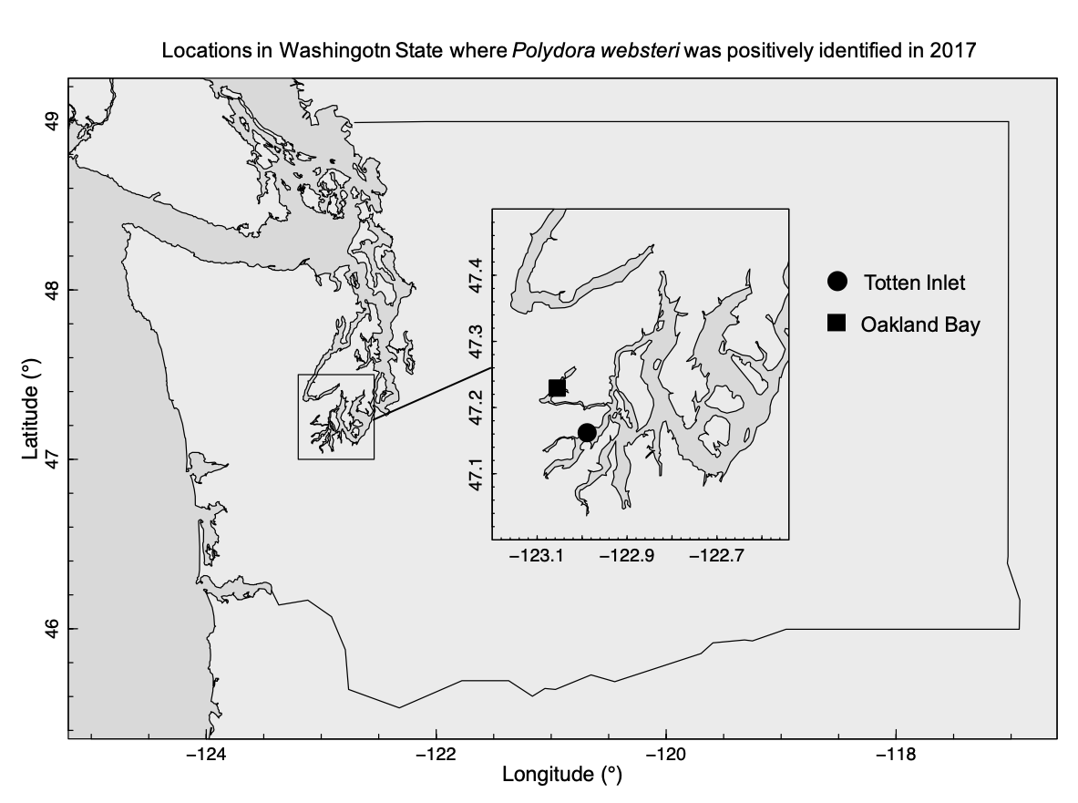

**Figure 1:** Washington state shellfish aquaculture regions and locations where *Polydora websteri* was positively identified during a preliminary survey in 2017.

TO DO: change large map to zoom in on coast, add shellfish aquaculture regions from Sea Grant 2015 report showing $ and % industry by region. Inset will show locations where P. websteri was found. *(Intent = Polydora found in importants shellfish region).*

**Figure 2.** A. *Crassostrea gigas* valve with three active *Polydora* burrows (red arrows indicate entry points) and B. *Crassostrea virginica* valve with many burrows. Both were sampled from Puget Sound, WA in 2017 (Martinelli et al. in review). Images courtesy of Heather Lopes and Julieta Martinelli. 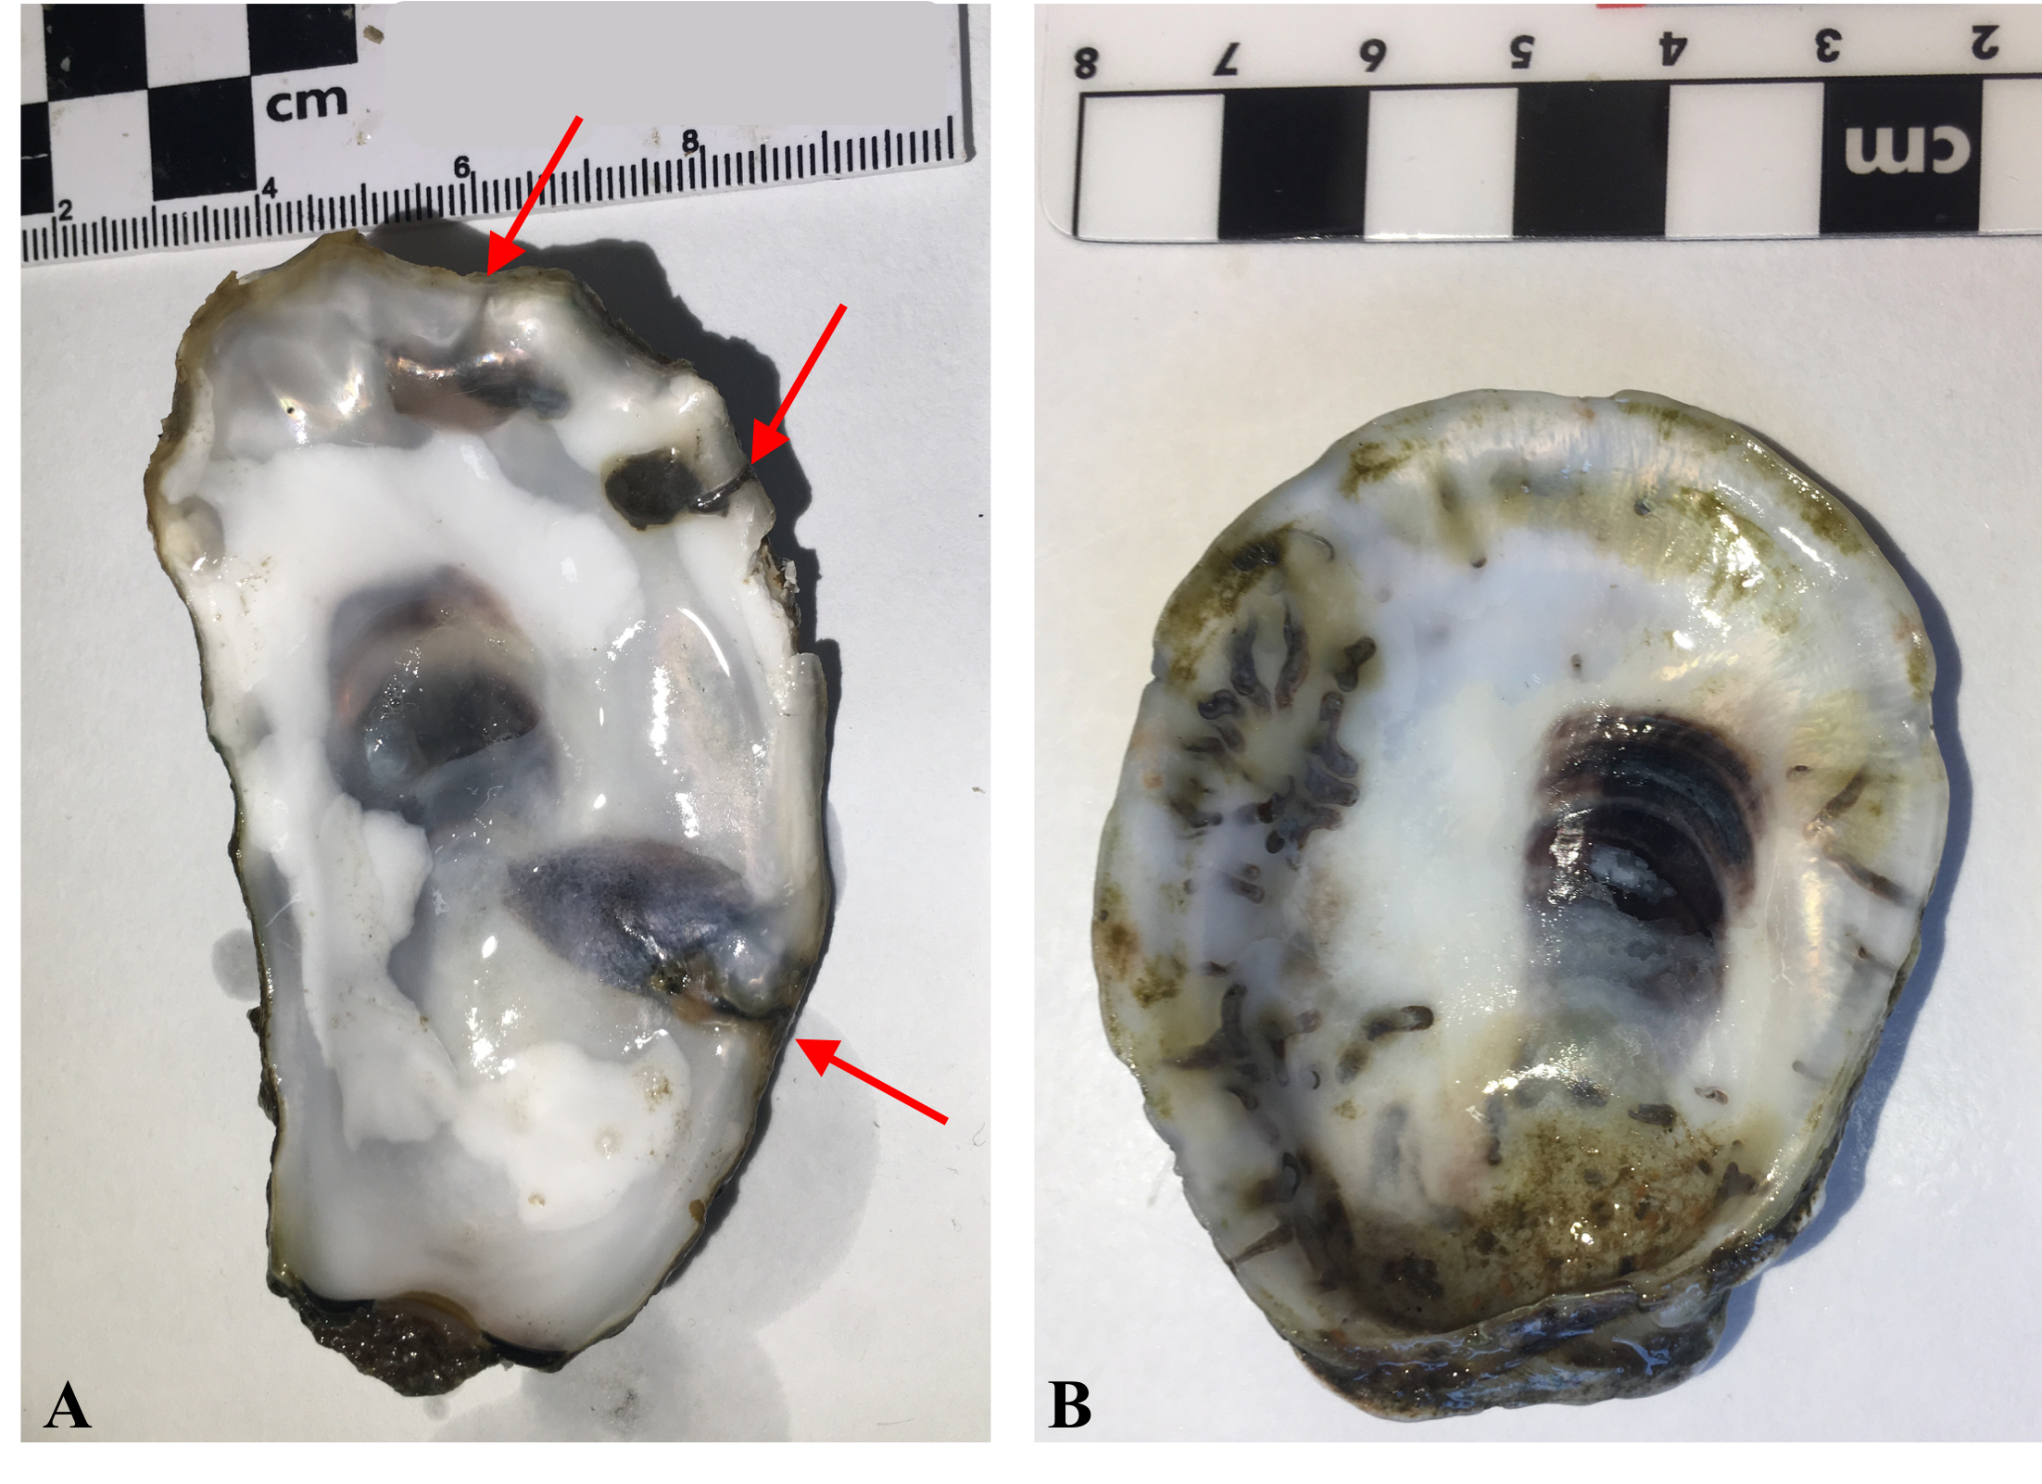

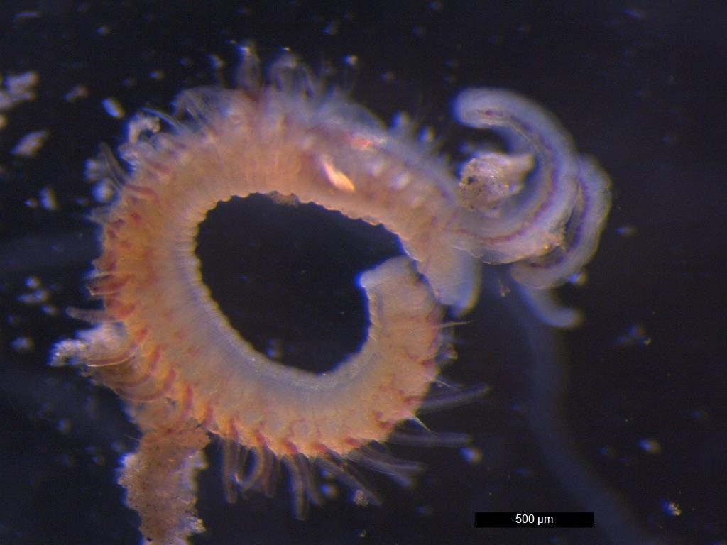

**Figure 3**. *Polydora websteri* found in *Crassostrea gigas* valve in Puget Sound, WA in 2017 (Martinelli et al. in review). Image courtesy of Heather Lopes and Julieta Martinelli.

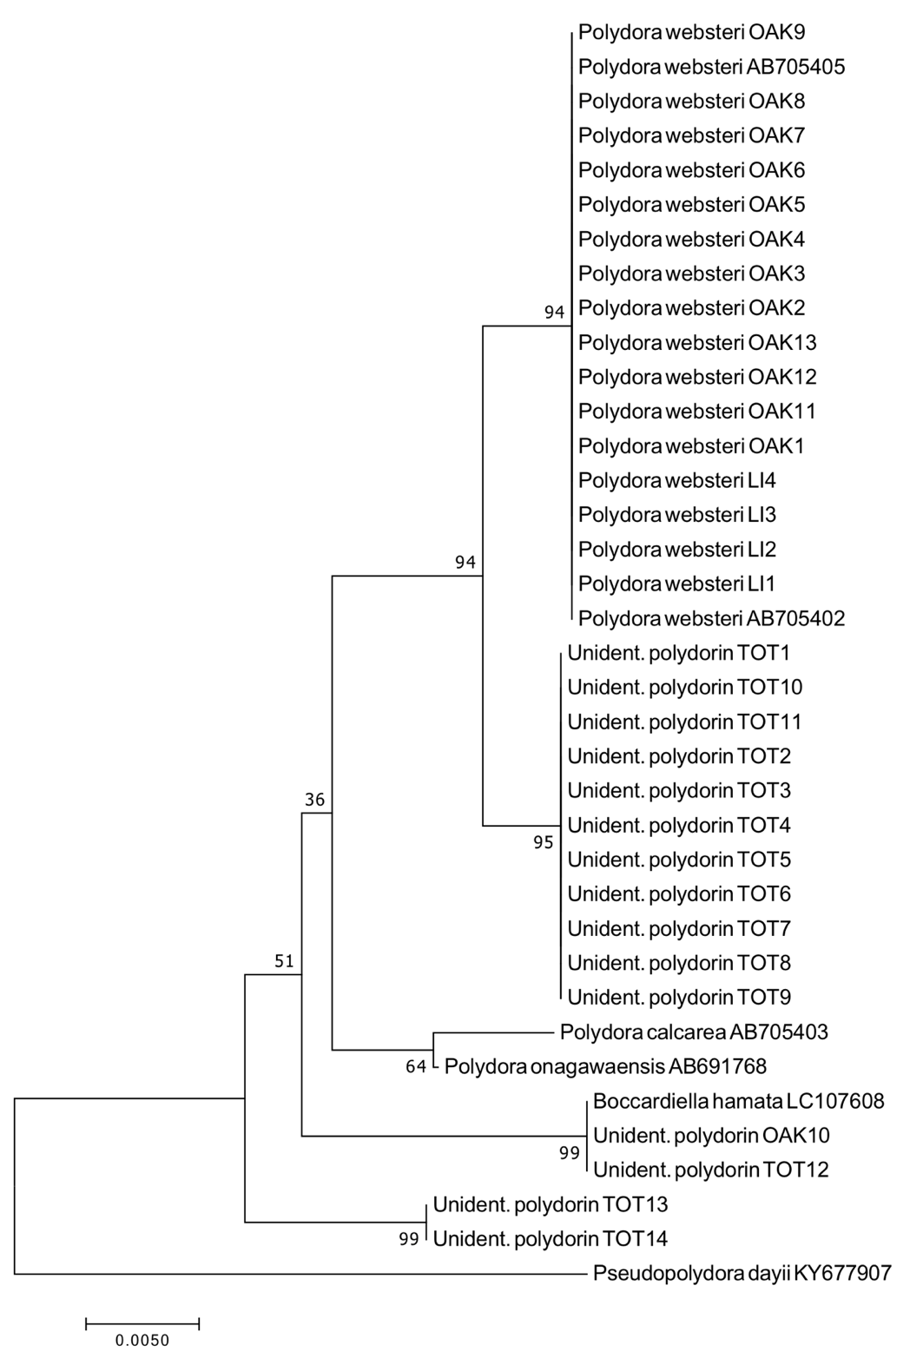

**Figure 4**: Maximum likelihood phylogeny based on Kimura 2-parameter distances using trimmed 18S1 rRNA sequences (1000 replicates). *Pseudopolydora dayii* (KY677907) was used as an outgroup. Entries accompanied with accession number were acquired from GenBank, individuals labeled with OAK and TOT were collected in Oakland Bay and Totten Inlet, respectively. *Reproduced from Martinelli et al. In review.*

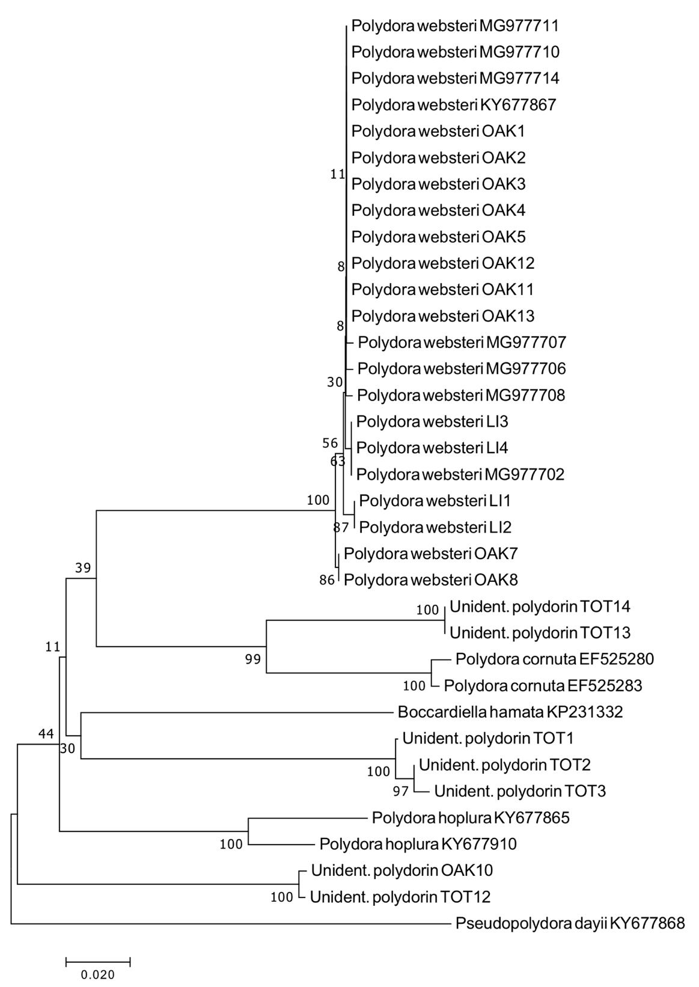

**Fig. 5***.* Maximum likelihood phylogeny based on Kimura 2-parameter method using trimmed mtCOI sequences (1000 replicates). *Pseudopolydora dayii* (KY677868) was used as an outgroup. Entries accompanied with accession number were acquired from GenBank, individuals labeled with OAK and TOT were collected in Oakland Bay and Totten Inlet, respectively. *Reproduced from Martinelli et al. In review*